Introducing the Airbnb 2021 Winter Release: 50+ upgrades and innovations across our entire service
AirCover, Translation Engine, and Accessibility Review are just a few of our new upgrades designed to improve the experience for guests and Hosts as the world undergoes a travel revolution

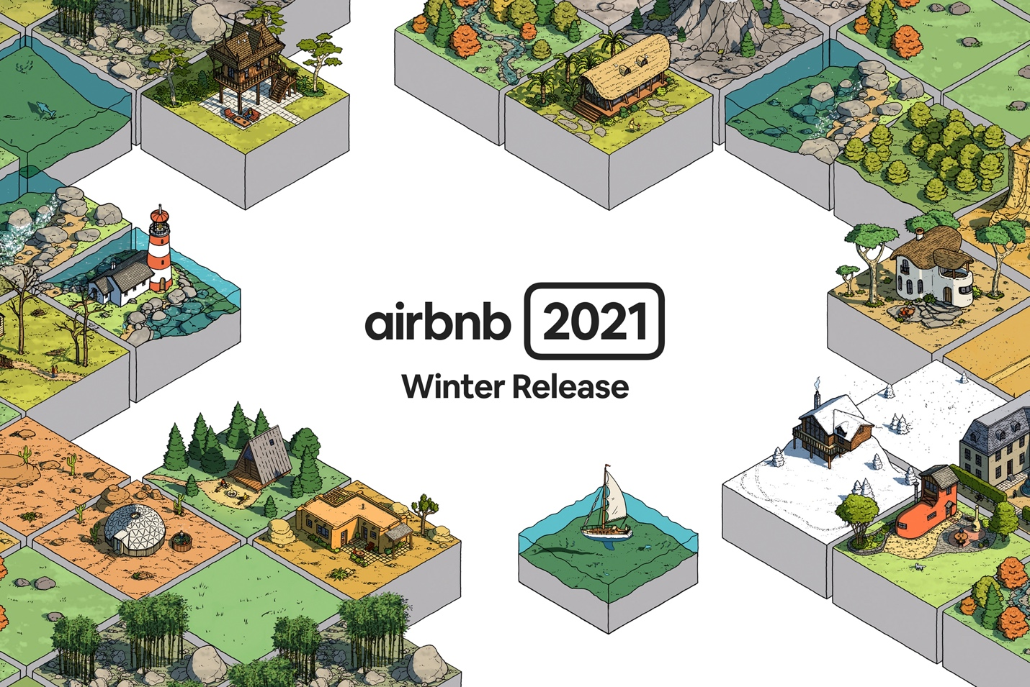

In May, we introduced the Airbnb 2021 Release, with over 100 upgrades to improve every aspect of the Airbnb service. Today, we are introducing the Airbnb 2021 Winter Release, with an additional 50+ upgrades that make it easier to host and support the changing needs of travelers.

The world is undergoing a revolution in how we live and work. Technologies like Zoom make it possible to work from home. Airbnb makes it possible to work from any home. This newfound flexibility is bringing about a revolution in how we travel. Millions of people can now take more frequent trips, longer trips, travel to more locations, and even live anywhere on Airbnb. In fact, 20% of our nights booked between July and September were for stays of a month or longer, and nearly half (45%) were for stays of at least a week.

We are constantly improving our service to meet this new way of traveling, and the wave of guests it will bring. Today, we are introducing:

- AirCover - Top-to-bottom protection. Free for every Host. Only on Airbnb.
- Translation Engine - The most advanced translation technology ever offered to our community.
- Accessibility Review - Every accessibility feature is reviewed for 100% accuracy.
- I’m (even more) Flexible - Search for more unique homes up to 12 months in advance.
- Verified Wifi - Our new speed test tool verifies the speed of the wifi in a listing.
- Smarter Trips Tab - A redesigned Trips tab with all your must-have travel details.
- Ask a Superhost Expansion - Connects new Hosts to a Superhost in their area for 1:1 help.

...and 46 more upgrades.

“For Airbnb, 2021 has been a year of relentless innovation to refine our core service,” said Brian Chesky, CEO and Co-Founder of Airbnb. “With the Airbnb 2021 Winter Release, we’ve delivered more than 150 upgrades and innovations this year. Our design-driven approach means that we’re constantly improving our service to adapt to this changing world. For the first time ever, millions of people can now travel anytime, anywhere, for any length, and even live anywhere on Airbnb. This is a travel revolution.”

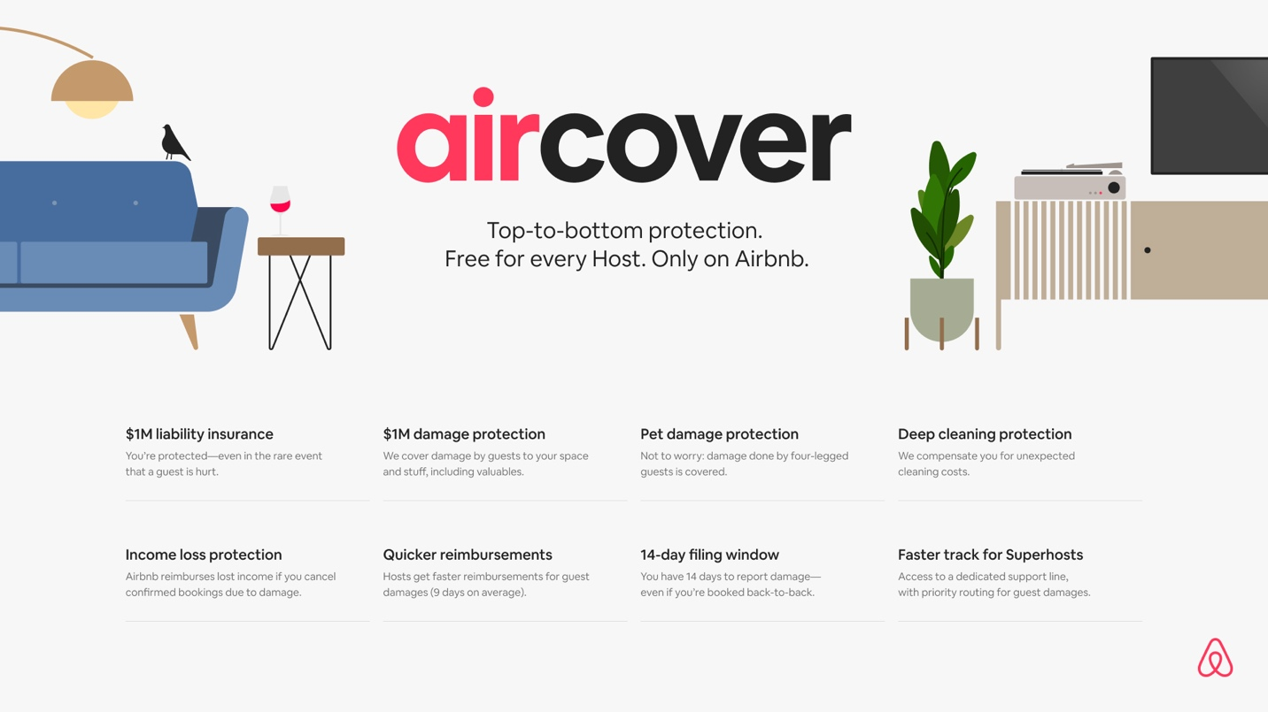

AirCover
More guests than ever before are choosing to stay in an Airbnb, which is leading to more people wanting to host to take advantage of this growing opportunity. To offer even more reassurance to our existing four million Hosts, and make it even easier for new Hosts to take that first big step, today we are introducing AirCover.

Only Airbnb gives you AirCover, which provides top-to-bottom protection for every Airbnb Host with $1 million in damage protection and $1 million in liability coverage. AirCover also includes income loss protection, pet damage protection, deep cleaning protection, and more.

Airbnb pioneered Host protection a decade ago with the industry-first Host Guarantee. After ten years of learning from our Hosts, we’ve reimagined the program, expanding protections and creating faster payouts.

AirCover is always included and always free for all new and existing Hosts. With AirCover, Hosts receive:
- $1M damage protection
- $1M liability insurance
- Income loss protection
- Pet damage protection
- Deep cleaning protection
- 14-day filing window
- Quicker reimbursements
- Faster track for Superhosts

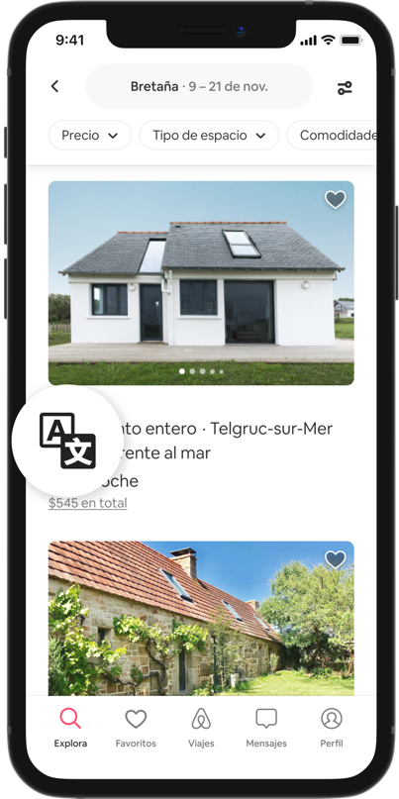

Translation Engine
As cross border travel returns, Airbnb’s new Translation Engine will provide a seamless experience for our Hosts and guests in over 60 languages. Translation Engine removes the need for click to translate buttons by automatically translating listing descriptions and reviews. Based on results from a study across our top ten languages we commissioned by a top machine translation evaluation company, Translation Engine improves the quality of more than 99% of Airbnb listings. Translation Engine uses millions of Airbnb data points to improve translations, so it will get even smarter over time as it learns from new content that’s submitted.

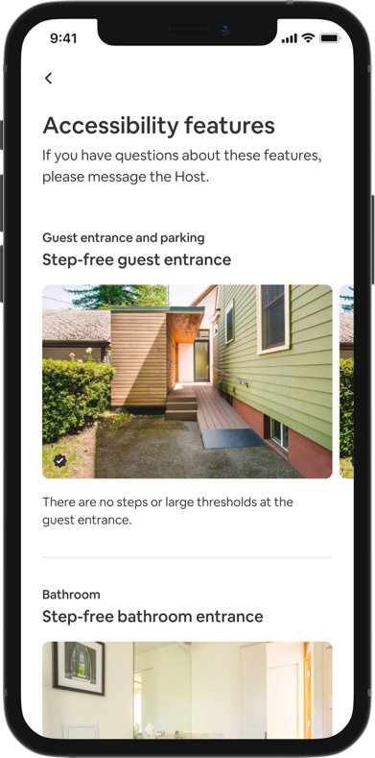
Accessibility Review
We’ve developed an industry-leading approach to review the accuracy of features that make Airbnb homes more accessible for our disability community. Hosts simply submit photos of their accessibility features, which are then manually reviewed by a specialized team of Airbnb agents. To date, Airbnb agents have reviewed and confirmed the accuracy of 100,000 accessibility features in 25,000 homes around the world.

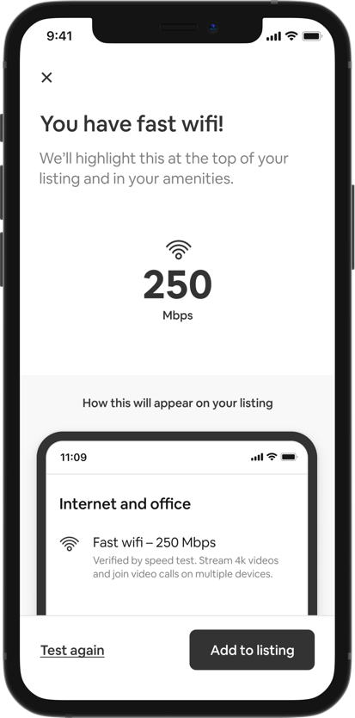

Verified Wifi
Fast and reliable wifi is more critical than ever before. In fact, this year guests on Airbnb have used the wifi filter more than 288 million times. Hosts can test their listing’s internet connection from the Airbnb app and have their wifi speed verified. With this upgrade, you can be confident that you won’t miss a Zoom or a favorite streaming show from your Airbnb.

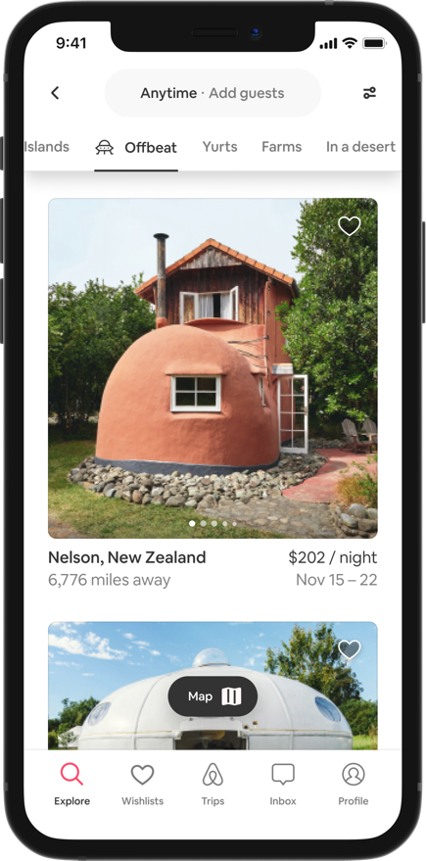

I’m (even more) Flexible
Earlier this year, we introduced I’m Flexible, a whole new way to search on Airbnb when you are flexible about where or when you are traveling. Since then, guests have used I’m Flexible more than 500 million times. Due to the popularity of this feature, today we are making it even more flexible by expanding the date range you can search to 12 months out (from six). We are also expanding I’m Flexible to include four new categories of unique stays: off the grid, ski-in/ski-out, luxe, and offbeat homes.

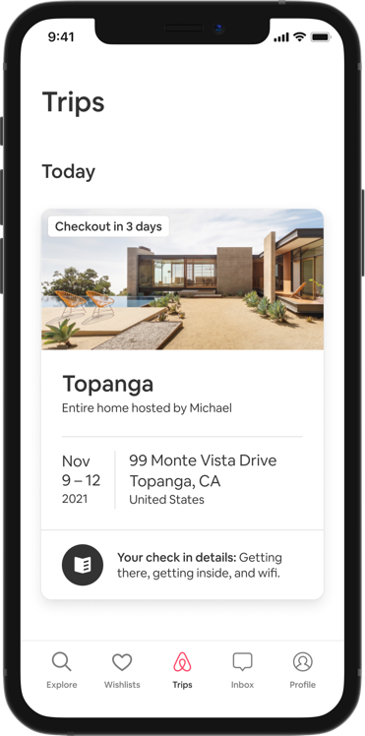
Smarter Trips Tab
We’ve redesigned the Trips tab to house all your must-have travel info in one convenient place. The smarter, more intuitive tab now features a handy countdown to your arrival, check-in details, current and upcoming reservations, and personalized Experiences suggestions. Spend less time planning, and more time enjoying the destination.

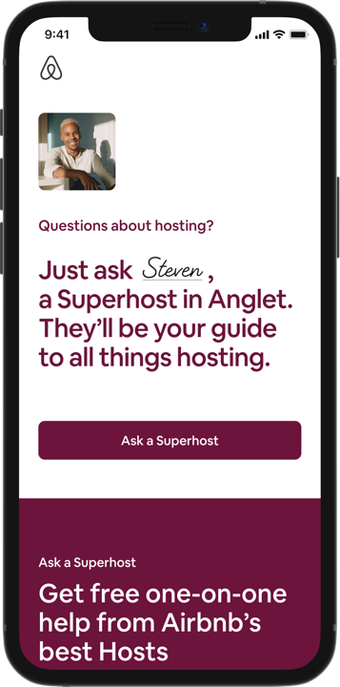
Ask a Superhost Expansion
Ask a Superhost matches anyone interested in hosting with one of our most experienced Hosts for one-on-one advice. Since launch, more than 60,000 prospective Hosts have used Ask a Superhost. Today, we’re expanding Ask a Superhost to over 30 languages in 196 countries. Prospective Hosts can now be paired with Superhosts based on their location, language, and listing. As an added benefit, Superhosts can provide tips for completing a listing page and are there for you through your first booking.

AirCover, Accessibility Review, Verified Wifi, I’m (even more) Flexible, and Ask a Superhost Expansion are all available to everyone today. Translation Engine and Smarter Trips Tab will launch before the end of this year.

