The Airbnb 2022 Summer Release: Introducing a new Airbnb for a new world of travel
With a new way to search designed around Airbnb Categories, the innovative Split Stays feature, and AirCover for guests, this launch represents the biggest change to Airbnb in a decade.

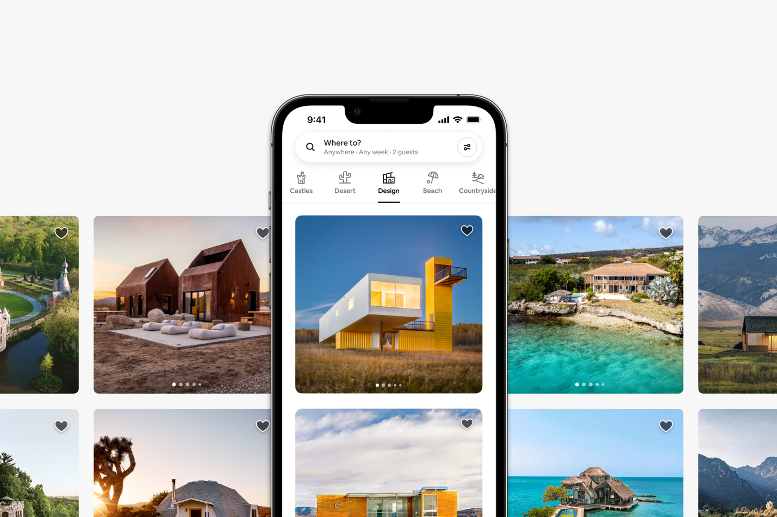

Last year, we released 150 upgrades to improve every aspect of the Airbnb service. Today, we are launching the biggest change to Airbnb in a decade including:

- Airbnb Categories - A new way to search that makes it easy to discover millions of homes you never knew existed.
- Split Stays - An innovative feature that provides more options for longer stays by splitting your trip between two homes.
- AirCover for guests - The most comprehensive protection in travel, included for free with every stay.

“The way people travel has changed forever. That’s why we’re introducing the biggest change to Airbnb in a decade,” said Brian Chesky, CEO and Co-Founder of Airbnb. “First, people are more flexible about where they live and work, so we’ve designed a new way to search with Airbnb Categories. Second, people are taking longer trips, so we created Split Stays to give you more options by splitting your trip between two homes. And third, we’re introducing AirCover for guests, giving you the confidence to book knowing that Airbnb’s got your back.”

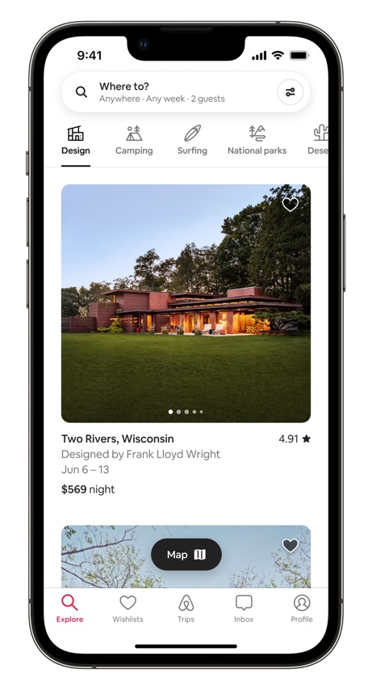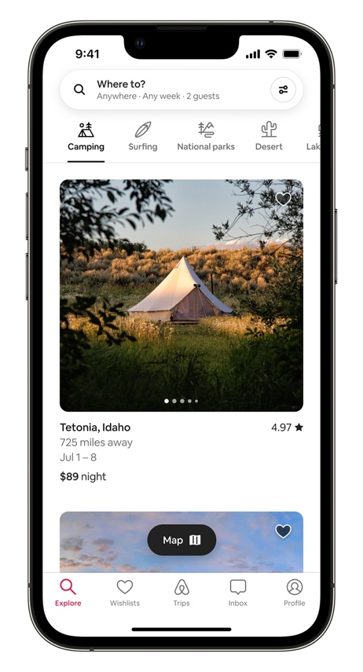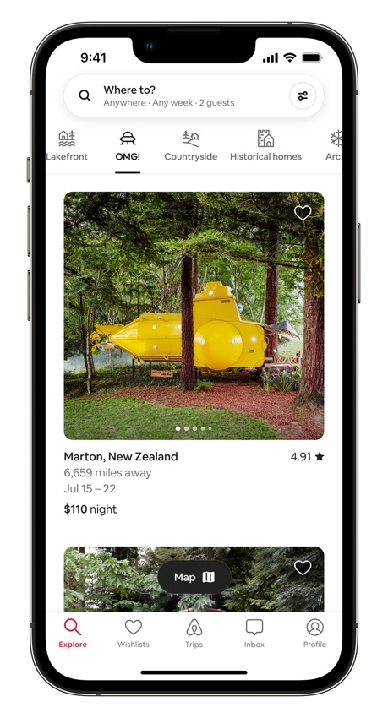

Airbnb Categories
Millions of people are now more flexible about where they live and work. But travel search has been the same for 25 years — you enter a location and dates into a search box. Most of us can only think of a few dozen cities to type into the search box, but there are Airbnbs in 100,000 towns and cities around the world.

That’s why we’re introducing a new way to search designed around Airbnb Categories, making it easy to discover millions of unique homes you never knew existed. When you open Airbnb, you’re presented with 56 categories that organize homes based on their style, location, or proximity to a travel activity. When you search for a destination, your search results are also organized by categories that are relevant to that destination. As you view different categories, the map intelligently zooms to show you where the homes are located.

To create Airbnb Categories, we evaluate millions of homes using machine learning to analyze titles, written descriptions, photo captions, structured data from Hosts, and reviews from guests. Members of Airbnb's curation team review listings and hand-pick featured photos — so if a listing is in the Amazing Pools Category, the first photo shows a pool. Then, each category goes through a final check to help ensure consistency and photo quality.

The 56 Airbnb Categories include more than 4 million unique homes that are made possible by our Hosts all around the world. Airbnb Categories organize homes by what makes them unique, which helps people discover places they wouldn't have otherwise found. This can help alleviate over-tourism by redistributing travel to new locations beyond the same popular destinations.
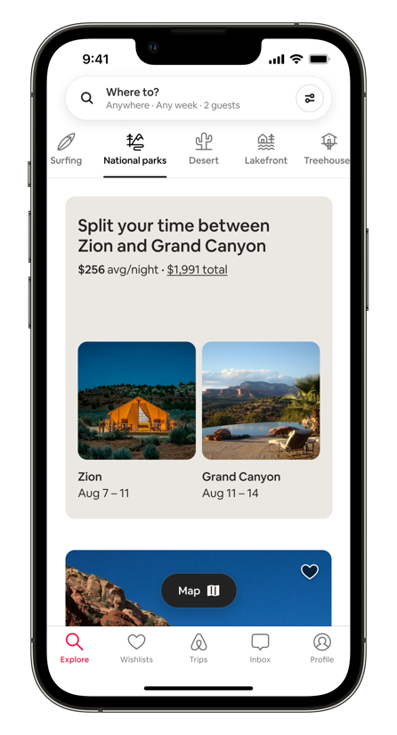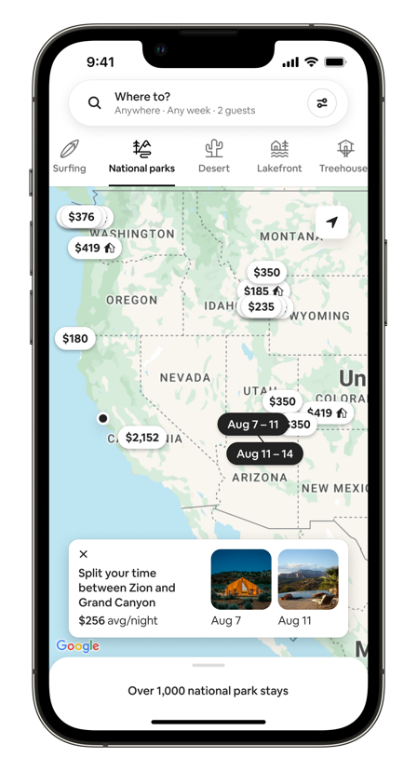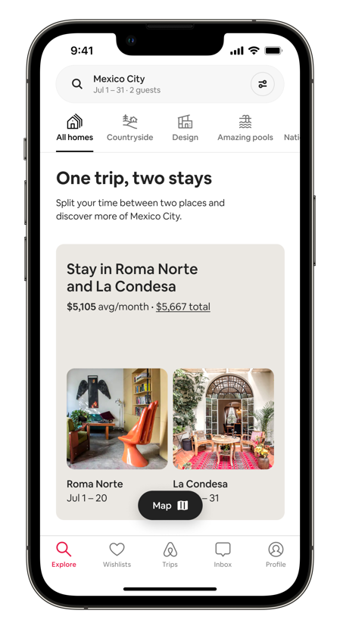
Two homes in one category. Animated mapping Two homes in one destination

Split Stays
In the last three months, nearly half of nights booked on Airbnb were for trips of a week or more. That's why we created Split Stays, an innovative feature that splits your trip between two homes. With Split Stays, you will typically see around 40% more listings when searching for longer stays.

When searching a specific destination, Split Stays automatically appear in your search results. They also appear within 14 categories — including Camping, National Parks, Skiing, and Surfing — to inspire you to stay in two destinations as part of a longer trip. For example, when browsing the National Parks Category, Split Stays might suggest a pair of homes near Zion National Park and Grand Canyon.

When viewing Split Stays on a map, an animated line visually connects the two homes to show you the distance between them and the sequence of the stays. Once you select a Split Stay, you’re guided through an easy-to-use interface to book each stay, one home at a time.
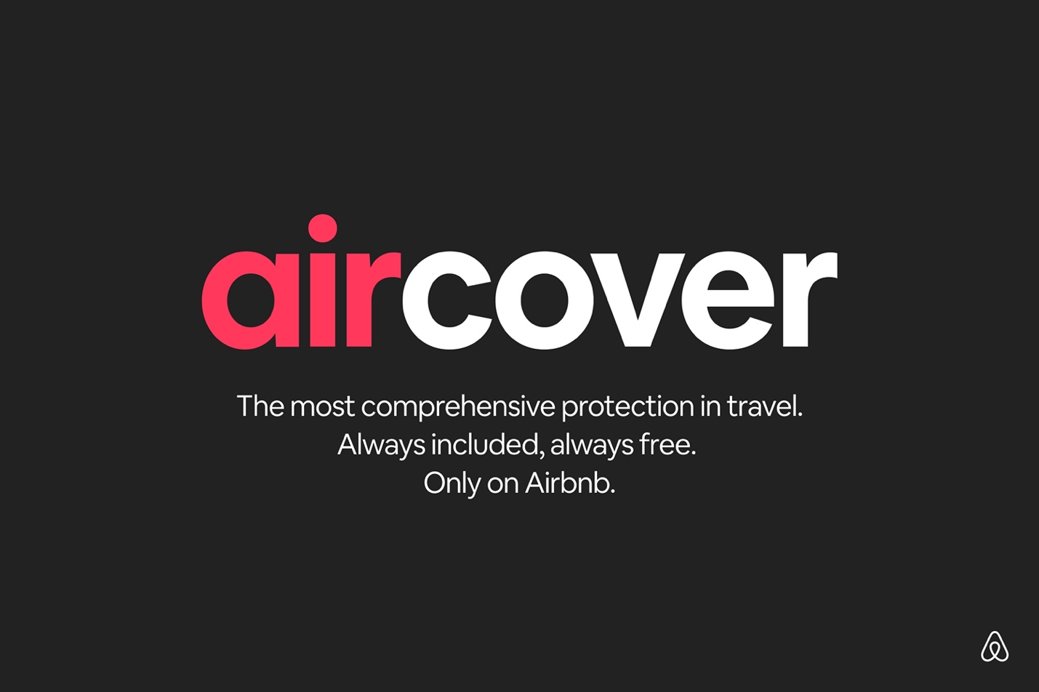

AirCover for Guests
This summer, millions of people will travel for the first time since the start of the pandemic. That's why we created AirCover, the most comprehensive protection in travel. AirCover is always included and always free, and it represents the biggest upgrade to Airbnb customer service in a decade.

With AirCover, you're covered by four protections every time you stay on Airbnb:

- Booking Protection Guarantee - In the unlikely event a Host needs to cancel your booking within 30 days of check-in, we’ll find you a similar or better home, or we’ll refund you.
- Check-In Guarantee - If you can’t check into your home and the Host cannot resolve the issue, we’ll find you a similar or better home for the length of your original stay, or we’ll refund you.
- Get-What-You-Booked Guarantee - If at any time during your stay you find your listing isn't as advertised — for example, the refrigerator stops working and your Host can’t easily fix it, or there are fewer bedrooms than listed — you'll have three days to report it and we’ll find you a similar or better home, or we’ll refund you.
- 24-hour Safety Line - If you ever feel unsafe, you’ll get priority access to specially-trained safety agents, day or night.

AirCover has been designed directly into the Airbnb app and website, making it easy for you to contact an agent and resolve issues quickly. We created a team of specially trained agents for last-minute rebooking assistance. We also significantly expanded our 24-hour safety line to cover 16 languages.

Available starting today
Airbnb’s redesigned app and website with 56 categories of unique homes, the innovative Split Stays feature, and AirCover for guests will be available worldwide this week, with rollout starting in the US today.

